Week -3
Here’s a simple explanation of that paragraph:
https://medium.com/the-modern-scientist/everything-you-need-to-know-about-openai-function-calling-and-assistants-api-55c02570a21c

resource-poc_function Irf chat

🧠 What is Function Calling (in simple words)?
- The AI doesn’t directly run functions (code).
- Instead, it creates a JSON request that says: 👉 “Call this function with these inputs.”

🔄 How it works step by step:
- User asks something
Example: “Book a flight to Delhi”
- AI understands the request
It decides a function is needed (like book_flight).
- AI creates a JSON output
{
"function": "book_flight",
"arguments": {
"destination": "Delhi"
}
}
- System executes the function
The actual backend runs book_flight("Delhi").
- Function returns result
Example: “Flight booked successfully”
- AI uses this result and replies to you
“Your flight to Delhi has been booked.”

✅ Key point:
👉 The AI only suggests what function to call (via JSON)
👉 The system actually executes it and gives the result

📦 One-line summary:
AI acts like a planner, not a doer—it tells which function to run and with what inputs, then uses the result to respond.

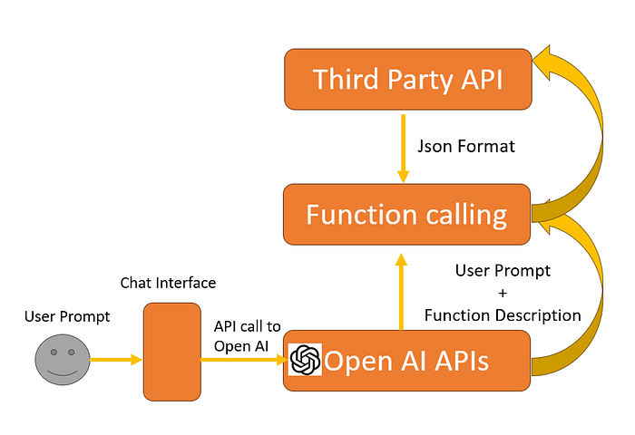
This diagram shows how an AI system (like OpenAI APIs) talks to other services using something called function calling. Here’s a very simple explanation step-by-step:

🧠 Big Idea (in one line)
Your message → AI understands it → AI decides to call a function → Gets data from another service → Gives answer back to you.

🔄 Step-by-step in simple words
1. 👤 User asks something
- You type a question (called a prompt) in a chat interface.
  - Example: “What is the weather today?”

2. 📩 Request goes to OpenAI APIs
- The chat interface sends your question to OpenAI (AI model).

3. 🤖 AI understands + checks functions
- The AI looks at:
  - Your question
  - Available functions (like “getWeather”)
- It decides: 👉 “Should I answer directly or call a function?”

4. 🔧 Function calling happens
- If needed, AI calls a function.
  - Example: getWeather(city="Hyderabad")
- This call is sent in JSON format (structured data).

5. 🌐 Third-party API is used
- The function talks to an external service (called Third Party API).
  - Example: Weather website API

6. 📦 Data comes back
- The third-party API returns data:
  - Example: temperature = 35°C

7. 🤖 AI formats the answer
- AI takes that data and converts it into a human-friendly reply.

8. 💬 You see the response
- Example: 👉 “The temperature in Hyderabad is 35°C.”

🧾 Simple Analogy
Think of it like a restaurant waiter:
- You = Customer 👤
- AI = Waiter 🤖
- Function = Kitchen order 🍳
- Third-party API = Kitchen 👨‍🍳
Flow:
- You order food
- Waiter takes order
- Waiter sends it to kitchen
- Kitchen prepares food
- Waiter brings food back

✅ Key Terms (Easy)
- Prompt = Your question
- Function calling = Asking another system to do work
- Third-party API = External service (weather, payment, maps, etc.)
- JSON = Simple structured format used to send data

If helpful, I can give a real coding example or a mini project using this 👍

